Chapter 8
Fundamentals of Capital Budgeting
8-1. Pisa Pizza, a seller of frozen pizza, is considering introducing a healthier version of its pizza that will be low in cholesterol and contain no trans fats. The firm expects that sales of the new pizza will be $20 million per year. While many of these sales will be to new customers, Pisa Pizza estimates that 40% will come from customers who switch to the new, healthier pizza instead of buying the original version.
a. Assume customers will spend the same amount on either version. What level of incremental sales is associated with introducing the new pizza?
b. Suppose that 50% of the customers who will switch from Pisa Pizza’s original pizza to its healthier pizza will switch to another brand if Pisa Pizza does not introduce a healthier pizza. What level of incremental sales is associated with introducing the new pizza in this case?
a. Sales of new pizza – lost sales of original = 20 – 0.40(20) = $12 million
b. Sales of new pizza – lost sales of original pizza from customers who would not have switched brands = 20 – 0.50(0.40)(20) = $16 million
8-2. Kokomochi is considering the launch of an advertising campaign for its latest dessert product, the Mini Mochi Munch. Kokomochi plans to spend $5 million on TV, radio, and print advertising this year for the campaign. The ads are expected to boost sales of the Mini Mochi Munch by $9 million this year and by $7 million next year. In addition, the company expects that new consumers who try the Mini Mochi Munch will be more likely to try Kokomochi’s other products. As a result, sales of other products are expected to rise by $2 million each year.
Kokomochi’s gross profit margin for the Mini Mochi Munch is 35%, and its gross profit margin averages 25% for all other products. The company’s marginal corporate tax rate is 35% both this year and next year. What are the incremental earnings associated with the advertising campaign?
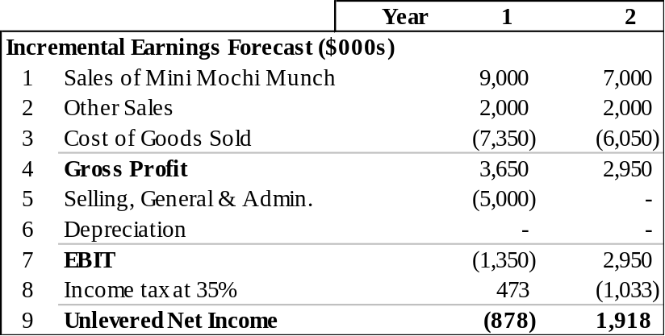
8-3. Home Builder Supply, a retailer in the home improvement industry, currently operates seven retail outlets in Georgia and South Carolina. Management is contemplating building an eighth retail store across town from its most successful retail outlet. The company already owns the land for this store, which currently has an abandoned warehouse located on it. Last month, the marketing department spent $10,000 on market research to determine the extent of customer demand for the new store. Now Home Builder Supply must decide whether to build and open the new store.
Which of the following should be included as part of the incremental earnings for the proposed new retail store?
a. The cost of the land where the store will be located.
b. The cost of demolishing the abandoned warehouse and clearing the lot.
c. The loss of sales in the existing retail outlet, if customers who previously drove across town to shop at the existing outlet become customers of the new store instead.
d. The $10,000 in market research spent to evaluate customer demand.
e. Construction costs for the new store.
f. The value of the land if sold.
g. Interest expense on the debt borrowed to pay the construction costs.
a. No, this is a sunk cost and will not be included directly. (But see (f) below.)
b. Yes, this is a cost of opening the new store.
c. Yes, this loss of sales at the existing store should be deducted from the sales at the new store to determine the incremental increase in sales that opening the new store will generate for HBS.
d. No, this is a sunk cost.
e. This is a capital expenditure associated with opening the new store. These costs will, therefore, increase HBS’s depreciation expenses.
f. Yes, this is an opportunity cost of opening the new store. (By opening the new store, HBS forgoes the after-tax proceeds it could have earned by selling the property. This loss is equal to the sale price less the taxes owed on the capital gain from the sale, which is the difference between the sale price and the book value of the property. The book value equals the initial cost of the property less accumulated depreciation.)
g. While these financing costs will affect HBS’s actual earnings, for capital budgeting purposes we calculate the incremental earnings without including financing costs to determine the project’s unlevered net income.
8-4. Hyperion, Inc. currently sells its latest high-speed color printer, the Hyper 500, for $350. It plans to lower the price to $300 next year. Its cost of goods sold for the Hyper 500 is $200 per unit, and this year’s sales are expected to be 20,000 units.
a. Suppose that if Hyperion drops the price to $300 immediately, it can increase this year’s sales by 25% to 25,000 units. What would be the incremental impact on this year’s EBIT of such a price drop?
b. Suppose that for each printer sold, Hyperion expects additional sales of $75 per year on ink cartridges for the next three years, and Hyperion has a gross profit margin of 70% on ink cartridges. What is the incremental impact on EBIT for the next three years of a price drop this year?
a. Change in EBIT = Gross profit with price drop – Gross profit without price drop
= 25,000 × (300 – 200) – 20,000 × (350 – 200)
= – $500,000
b. Change in EBIT from ink cartridge sales = 25,000 × $75 × 0.70 – 20,000 × $75 × 0.70 = $262,500
Therefore, incremental change in EBIT for the next three years is
Year 1: $262,500 – 500,000 = -$237,500
Year 2: $262,500
Year 3: $262,500

8-5. After looking at the projections of the HomeNet project, you decide that they are not realistic. It is unlikely that sales will be constant over the four-year life of the project. Furthermore, other companies are likely to offer competing products, so the assumption that the sales price will remain constant is also likely to be optimistic. Finally, as production ramps up, you anticipate lower per unit production costs resulting from economies of scale. Therefore, you decide to redo the projections under the following assumptions: Sales of 50,000 units in year 1 increasing by 50,000 units per year over the life of the project, a year 1 sales price of $260/unit, decreasing by 10% annually and a year 1 cost of $120/unit decreasing by 20% annually. In addition, new tax laws allow you to depreciate the equipment over three rather than five years using straight-line depreciation.
a. Keeping the other assumptions that underlie Table 8.1 the same, recalculate unlevered net income (that is, reproduce Table 8.1 under the new assumptions, and note that we are ignoring cannibalization and lost rent).
b. Recalculate unlevered net income assuming, in addition, that each year 20% of sales comes from customers who would have purchased an existing Linksys router for $100/unit and that this router costs $60/unit to manufacture.
a.
 |  | Year | 0 | 1 | 2 | 3 | 4 | 5
Incremental Earnings Forecast ($000s)
1 | Sales |  | - | 13,000 | 23,400 | 31,590 | 37,908 | -
2 | Cost of Goods Sold |  |  | (6,000) | (9,600) | (11,520) | (12,288) | -
3 | Gross Profit |  | - | 7,000 | 13,800 | 20,070 | 25,620 | -
4 | Selling, General & Admin. |  | - | (2,800) | (2,800) | (2,800) | (2,800) | -
5 | Research & Development |  | (15,000) | - | - | - | - | -
6 | Depreciation |  | - | (2,500) | (2,500) | (2,500) | - | -
7 | EBIT |  | (15,000) | 1,700 | 8,500 | 14,770 | 22,820 | -
8 | Income tax at 40% |  | 6,000 | (680) | (3,400) | (5,908) | (9,128) | -
9 | Unlevered Net Income |  | (9,000) | 1,020 | 5,100 | 8,862 | 13,692 | -

b.
 |  | Year | 0 | 1 | 2 | 3 | 4 | 5
Incremental Earnings Forecast ($000s)
1 | Sales |  | - | 12,000 | 21,400 | 28,590 | 33,908 | -
2 | Cost of Goods Sold |  |  | (5,400) | (8,400) | (9,720) | (9,888) | -
3 | Gross Profit |  | - | 6,600 | 13,000 | 18,870 | 24,020 | -
4 | Selling, General & Admin. |  | - | (2,800) | (2,800) | (2,800) | (2,800) | -
5 | Research & Development |  | (15,000) | - | - | - | - | -
6 | Depreciation |  | - | (2,500) | (2,500) | (2,500) | - | -
7 | EBIT |  | (15,000) | 1,300 | 7,700 | 13,570 | 21,220 | -
8 | Income tax at 40% |  | 6,000 | (520) | (3,080) | (5,428) | (8,488) | -
9 | Unlevered Net Income |  | (9,000) | 780 | 4,620 | 8,142 | 12,732 | -
8-6. Cellular Access, Inc. is a cellular telephone service provider that reported net income of $250 million for the most recent fiscal year. The firm had depreciation expenses of $100 million, capital expenditures of $200 million, and no interest expenses. Working capital increased by $10 million. Calculate the free cash flow for Cellular Access for the most recent fiscal year.
FCF = Unlevered Net Income + Depreciation – CapEx – Increase in NWC= 250 + 100 – 200 – 10 = $140 million.
8-7. Castle View Games would like to invest in a division to develop software for video games. To evaluate this decision, the firm first attempts to project the working capital needs for this operation. Its chief financial officer has developed the following estimates (in millions of dollars):
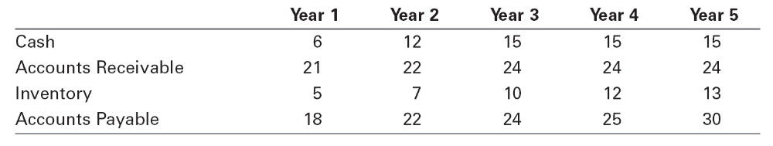
Assuming that Castle View currently does not have any working capital invested in this division, calculate the cash flows associated with changes in working capital for the first five years of this investment.
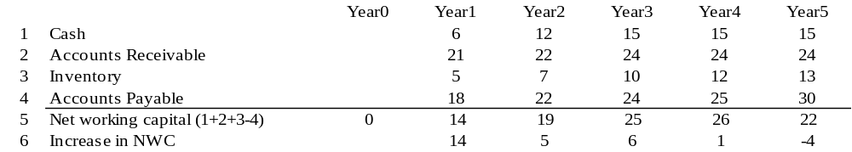
8-8. Mersey Chemicals manufactures polypropylene that it ships to its customers via tank car. Currently, it plans to add two additional tank cars to its fleet four years from now. However, a proposed plant expansion will require Mersey’s transport division to add these two additional tank cars in two years’ time rather than in four years. The current cost of a tank car is $2 million, and this cost is expected to remain constant. Also, while tank cars will last indefinitely, they will be depreciated straight-line over a five-year life for tax purposes. Suppose Mersey’s tax rate is 40%. When evaluating the proposed expansion, what incremental free cash flows should be included to account for the need to accelerate the purchase of the tank cars?
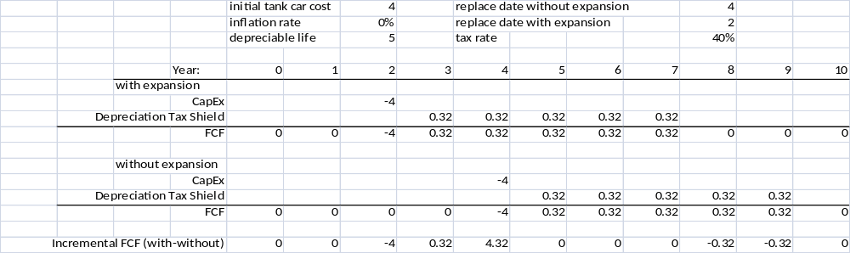
8-9. Elmdale Enterprises is deciding whether to expand its production facilities. Although long-term cash flows are difficult to estimate, management has projected the following cash flows for the first two years (in millions of dollars):
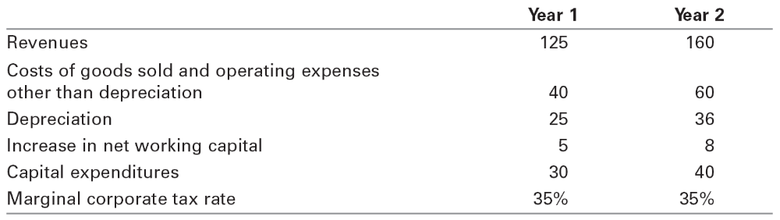
a. What are the incremental earnings for this project for years 1 and 2?
b. What are the free cash flows for this project for the first two years?
a.
 |  | Year | 1 | 2
Incremental Earnings Forecast ($000s)
1 | Sales |  | 125.0 | 160.0
2 | Costs of good sold and operating expenses other than depreciation |  | (40.0) | (60.0)
3 | Depreciation |  | (25.0) | (36.0)
4 | EBIT |  | 60.0 | 64.0
5 | Income tax at 35% |  | (21.0) | (22.4)
6 | Unlevered Net Income |  | 39.0 | 41.6
b.
Free Cash Flow ($000s) |  |  | 1 | 2
7 | Plus: Depreciation |  | 25.0 | 36.0
8 | Less: Capital Expenditures |  | (30.0) | (40.0)
9 | Less: Increases in NWC |  | (5.0) | (8.0)
10 | Free Cash Flow |  | 29.0 | 29.6
8-10. You are a manager at Percolated Fiber, which is considering expanding its operations in synthetic fiber manufacturing. Your boss comes into your office, drops a consultant’s report on your desk, and complains, “We owe these consultants $1 million for this report, and I am not sure their analysis makes sense. Before we spend the $25 million on new equipment needed for this project, look it over and give me your opinion.” You open the report and find the following estimates (in thousands of dollars):
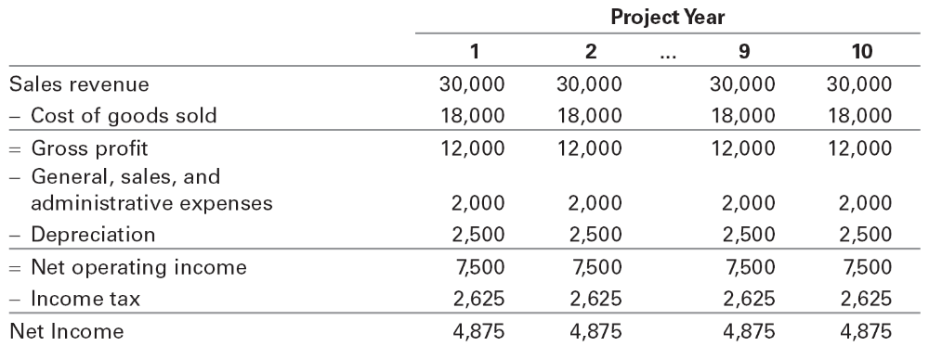
All of the estimates in the report seem correct. You note that the consultants used straight-line depreciation for the new equipment that will be purchased today (year 0), which is what the accounting department recommended. The report concludes that because the project will increase earnings by $4.875 million per year for 10 years, the project is worth $48.75 million. You think back to your halcyon days in finance class and realize there is more work to be done!
First, you note that the consultants have not factored in the fact that the project will require $10 million in working capital upfront (year 0), which will be fully recovered in year 10. Next, you see they have attributed $2 million of selling, general and administrative expenses to the project, but you know that $1 million of this amount is overhead that will be incurred even if the project is not accepted. Finally, you know that accounting earnings are not the right thing to focus on!
a. Given the available information, what are the free cash flows in years 0 through 10 that should be used to evaluate the proposed project?
b. If the cost of capital for this project is 14%, what is your estimate of the value of the new project?
a. Free Cash Flows are:
 | 0 | 1 | 2 | … | 9 | 10
= Net income |  | 4,875 | 4,875 |  | 4,875 | 4,875
+ Overhead (after tax at 35%) |  | 650 | 650 |  | 650 | 650
+ Depreciation |  | 2,500 | 2,500 |  | 2,500 | 2,500
– Capex | 25,000
– Inc. in NWC | 10,000 |  |  |  |  | –10000
FCF | –35,000 | 8,025 | 8,025 | … | 8,025 | 18,025
b. 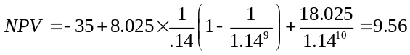
8-11. Using the assumptions in part (a) of Problem 5 (assuming there is no cannibalization),
a. Calculate HomeNet’s net working capital requirements (that is, reproduce Table 8.4 under the assumptions in Problem 5(a)).
b. Calculate HomeNet’s FCF (that is, reproduce Table 8.3 under the same assumptions as in (a)).
a.
 |  |  | Year | 0 | 1 | 2 | 3 | 4 | 5
Net Working Capital Forecast ($000s)
1 | Cash requirements |  |  | - | - | - | - | - | -
2 | Inventory |  |  | - | - | - | - | - | -
3 | Receivables (15% of Sales) |  |  | - | 1,950 | 3,510 | 4,739 | 5,686 | -
4 | Payables (15% of COGS) |  |  | - | (900) | (1,440) | (1,728) | (1,843) | -
5 | Net Working Capital |  |  | - | 1,050 | 2,070 | 3,011 | 3,843 | -
b.
 |  | Year |  | 0 |  | 1 | 2 | 3 | 4 | 5
Incremental Earnings Forecast ($000s)
1 | Sales |  |  | - |  | 13,000 | 23,400 | 31,590 | 37,908 | -
2 | Cost of Goods Sold |  |  |  |  | (6,000) | (9,600) | (11,520) | (12,288) | -
3 | Gross Profit |  |  | - |  | 7,000 | 13,800 | 20,070 | 25,620 | -
4 | Selling, General & Admin. |  |  | - |  | (2,800) | (2,800) | (2,800) | (2,800) | -
5 | Research & Development |  |  | (15,000) |  | - | - | - | - | -
6 | Depreciation |  |  | - |  | (2,500) | (2,500) | (2,500) | - | -
7 | EBIT |  |  | (15,000) |  | 1,700 | 8,500 | 14,770 | 22,820 | -
8 | Incometaxat40% |  |  | 6,000 |  | (680) | (3,400) | (5,908) | (9,128) | -
9 | Unlevered Net Income |  |  | (9,000) |  | 1,020 | 5,100 | 8,862 | 13,692 | -
Free Cash Flow ($000s)
10 | Plus: Depreciation |  |  | - |  | 2,500 | 2,500 | 2,500 | - | -
11 | Less: Capital Expenditures |  |  | (7,500) |  | - | - | - | - | -
12 | Less: Increases in NWC |  |  | - |  | (1,050) | (1,020) | (941) | (833) | 3,843
13 | Free Cash Flow |  |  | (16,500) |  | 2,470 | 6,580 | 10,421 | 12,860 | 3,843
8-12. A bicycle manufacturer currently produces 300,000 units a year and expects output levels to remain steady in the future. It buys chains from an outside supplier at a price of $2 a chain. The plant manager believes that it would be cheaper to make these chains rather than buy them. Direct in-house production costs are estimated to be only $1.50 per chain. The necessary machinery would cost $250,000 and would be obsolete after 10 years. This investment could be depreciated to zero for tax purposes using a 10-year straight-line depreciation schedule. The plant manager estimates that the operation would require additional working capital of $50,000 but argues that this sum can be ignored since it is recoverable at the end of the 10 years. Expected proceeds from scrapping the machinery after 10 years are $20,000.
If the company pays tax at a rate of 35% and the opportunity cost of capital is 15%, what is the net present value of the decision to produce the chains in-house instead of purchasing them from the supplier?
Solution: FCF = EBIT (1 – t) + depreciation – CAPX – NWC
FCF from outside supplier = -$2 × 300,000 × (1 – .35) = –$390k per year.
NPV(outside) 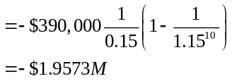
FCF in-house:
in year 0: – 250 CAPX – 50 NWC= – 300K
FCF in years 1–9: | 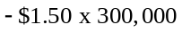 | cost
 | 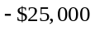 | −depreciation
 | -$475,000 | = incremental EBIT
 | 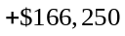 | − tax
 | -$308,750 | = (1-t) x EBIT
 | +$25,000 | + depreciation
 | -$283,750 | = FCF

FCF in year 10: –$283,750 + (1 – 0.35) × $20,000 + $50,000 = –$220,750 FCF
Note that the book value of the machinery is zero; hence, its scrap proceeds ($20,000) are fully taxed.
The NWC ($50,000) is recovered at book value and hence not taxed.
NPV (in-house): –$300k
+ annuity of –$283,750 for 9 years
+ 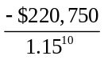
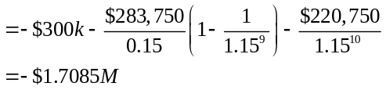
Thus, in-house is cheaper, with a cost savings of ($1.9573M – $1.7085M) = $248.8K in present value terms.
8-13. One year ago, your company purchased a machine used in manufacturing for $110,000. You have learned that a new machine is available that offers many advantages; you can purchase it for $150,000 today. It will be depreciated on a straight-line basis over 10 years, after which it has no salvage value. You expect that the new machine will produce EBITDA (earning before interest, taxes, depreciation, and amortization) of $40,000 per year for the next 10 years. The current machine is expected to produce EBITDA of $20,000 per year. The current machine is being depreciated on a straight-line basis over a useful life of 11 years, after which it will have no salvage value, so depreciation expense for the current machine is $10,000 per year. All other expenses of the two machines are identical. The market value today of the current machine is $50,000. Your company’s tax rate is 45%, and the opportunity cost of capital for this type of equipment is 10%. Is it profitable to replace the year-old machine?
Replacing the machine increases EBITDA by 40,000 – 20,000 = 20,000. Depreciation expenses rise by $15,000 – $10,000 = $5,000. Therefore, FCF will increase by (20,000) × (1-0.45) + (0.45)(5,000) = $13,250 in years 1 through 10.
In year 0, the initial cost of the machine is $150,000. Because the current machine has a book value of $110,000 – 10,000 (one year of depreciation) = $100,000, selling it for $50,000 generates a capital gain of 50,000 – 100,000 = –50,000. This loss produces tax savings of 0.45 × 50,000 = $22,500, so that the after-tax proceeds from the sales, including this tax savings, is $72,500. Thus, the FCF in year 0 from replacement is
–150,000 + 72,500 = –$77,500.
NPV of replacement = –77,500 + 13,250 × (1 / .10)(1 – 1 / 1.10¹⁰) = $3916. There is a small profit from replacing the machine.
8-14. Beryl’s Iced Tea currently rents a bottling machine for $50,000 per year, including all maintenance expenses. It is considering purchasing a machine instead, and is comparing two options:
a. Purchase the machine it is currently renting for $150,000. This machine will require $20,000 per year in ongoing maintenance expenses.
b. Purchase a new, more advanced machine for $250,000. This machine will require $15,000 per year in ongoing maintenance expenses and will lower bottling costs by $10,000 per year. Also, $35,000 will be spent upfront in training the new operators of the machine.
Suppose the appropriate discount rate is 8% per year and the machine is purchased today. Maintenance and bottling costs are paid at the end of each year, as is the rental of the machine. Assume also that the machines will be depreciated via the straight-line method over seven years and that they have a 10-year life with a negligible salvage value. The marginal corporate tax rate is 35%. Should Beryl’s Iced Tea continue to rent, purchase its current machine, or purchase the advanced machine?
We can use Eq. 8.5 to evaluate the free cash flows associated with each alternative. Note that we only need to include the components of free cash flows that vary across each alternative. For example, since NWC is the same for each alternative, we can ignore it.
The spreadsheet below computes the relevant FCF from each alternative. Note that each alternative has a negative NPV—this represents the PV of the costs of each alternative. We should choose the one with the highest NPV (lowest cost), which in this case is purchasing the existing machine.
a. See spreadsheet
b. See spreadsheet
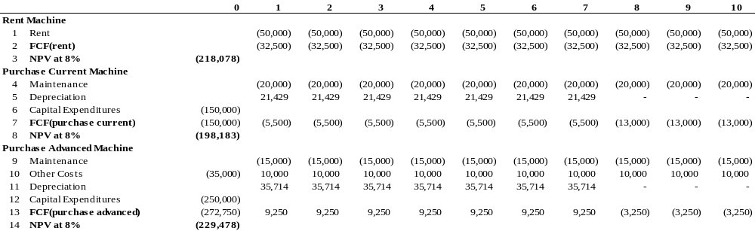
8-15. Markov Manufacturing recently spent $15 million to purchase some equipment used in the manufacture of disk drives. The firm expects that this equipment will have a useful life of five years, and its marginal corporate tax rate is 35%. The company plans to use straight-line depreciation.
a. What is the annual depreciation expense associated with this equipment?
b. What is the annual depreciation tax shield?
c. Rather than straight-line depreciation, suppose Markov will use the MACRS depreciation method for five-year property. Calculate the depreciation tax shield each year for this equipment under this accelerated depreciation schedule.
d. If Markov has a choice between straight-line and MACRS depreciation schedules, and its marginal corporate tax rate is expected to remain constant, which should it choose? Why?
e. How might your answer to part (d) change if Markov anticipates that its marginal corporate tax rate will increase substantially over the next five years?
a. $15 million / 5 years = $3 million per year
b. $3 million × 35% = $1.05 million per year
c.
Year | 0 | 1 | 2 | 3 | 4 | 5
MACRS Depreciation
Equipment Cost | 15,000
MACRS Depreciation Rate | 20.00% | 32.00% | 19.20% | 11.52% | 11.52% | 5.76%
Depreciation Expense | 3,000 | 4,800 | 2,880 | 1,728 | 1,728 | 864
Depreciation Tax Shield (at 35%  tax rate) | 1,050 | 1,680 | 1,008 | 605 | 605 | 302
d. In both cases, its total depreciation tax shield is the same. But with MACRS, it receives the depreciation tax shields sooner—thus, MACRS depreciation leads to a higher NPV of Markov’s FCF.
e. If the tax rate will increase substantially, then Markov may be better off claiming higher depreciation expenses in later years, since the tax benefit at that time will be greater.
8-16. Your firm is considering a project that would require purchasing $7.5 million worth of new equipment. Determine the present value of the depreciation tax shield associated with this equipment if the firm’s tax rate is 40%, the appropriate cost of capital is 8%, and the equipment can be depreciated:
a. Straight-line over a 10-year period, with the first deduction starting in one year.
b. Straight-line over a five-year period, with the first deduction starting in one year.
c. Using MACRS depreciation with a five-year recovery period and starting immediately.
d. Fully as an immediate deduction.
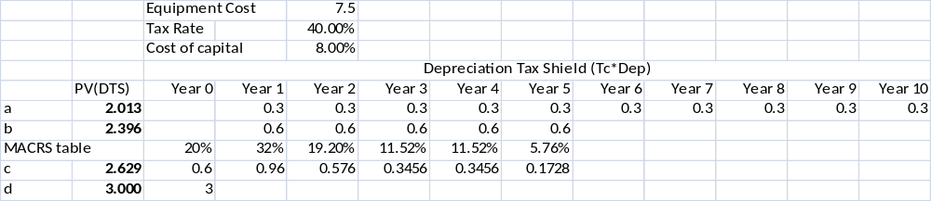
8-17. Arnold Inc. is considering a proposal to manufacture high-end protein bars used as food supplements by body builders. The project requires use of an existing warehouse, which the firm acquired three years ago for $1 million and which it currently rents out for $120,000. Rental rates are not expected to change going forward. In addition to using the warehouse, the project requires an up-front investment into machines and other equipment of $1.4m. This investment can be fully depreciated straight-line over the next 10 years for tax purposes. However, Arnold Inc. expects to terminate the project at the end of eight years and to sell the machines and equipment for $500,000. Finally, the project requires an initial investment into net working capital equal to 10% of predicted first-year sales. Subsequently, net working capital is 10% of the predicted sales over the following year. Sales of protein bars are expected to be $4.8 million in the first year and to stay constant for eight years. Total manufacturing costs and operating expenses (excluding depreciation) are 80% of sales, and profits are taxed at 30%.
a. What are the free cash flows of the project?
b. If the cost of capital is 15%, what is the NPV of the project?
a. Assumptions:
(1) The warehouse can be rented out again for $120,000 after 8 years.
(2) The NWC is fully recovered at book value after 8 years.
FCF = EBIT (1 – t) + Depreciation – CAPX – Change in NWC
FCF in year 0: – 1.4m CAPX – 0.48m Change in NWC = –1.88m

FCF in years 1-7: | $4.8m | Sales
 | –$3.84m | –Cost (80%)
 | $0.96m | =Gross Profit
 | –$0.12m | –Lost Rent
 | –$0.14m | –Depreciation
 | $0.70m | =EBIT
 | –$0.21m | –Tax (30%)
 | $0.49m | = (1 – t) x EBIT
 | $0.14m | +Depreciation
 | $0.63m | = FCF

Note that there is no more CAPX nor investment into NWC in years 1–7.
FCF in year 8: $0.63m + [$0.5m – 0.30 × ($0.5m – $0.28m)] + $0.48m = $1.544m
Note that the book value of the machinery is still $0.28m when sold, and only the difference between the sale price ($0.5m) and the book value is taxed.
The NWC ($0.48m) is recovered at book value and hence its sale is not taxed at all.
b. The NPV is the present value of the FCFs in years 0 to 8:
NPV= -$1.88m
+ an annuity of $0.63m for 7 years
+ 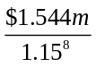
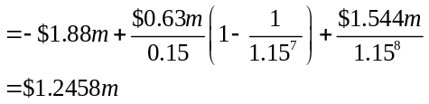
8-18. Bay Properties is considering starting a commercial real estate division. It has prepared the following four-year forecast of free cash flows for this division:
Assume cash flows after year 4 will grow at 3% per year, forever. If the cost of capital for this division is 14%, what is the continuation value in year 4 for cash flows after year 4? What is the value today of this division?
The expected cash flow in year 5 is 240,000 × 1.03 = 247,200. We can value the cash flows in year 5 and beyond as a growing perpetuity:
Continuation Value in Year 4 = 247,200/(0.14 – 0.03) = $2,247,273
We can then compute the value of the division by discounting the FCF in years 1 through 4, together with the continuation value:
8-19. Your firm would like to evaluate a proposed new operating division. You have forecasted cash flows for this division for the next five years, and have estimated that the cost of capital is 12%. You would like to estimate a continuation value. You have made the following forecasts for the last year of your five-year forecasting horizon (in millions of dollars):
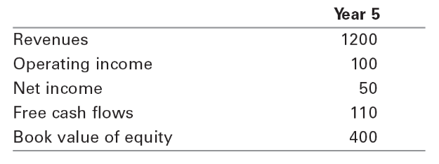
a. You forecast that future free cash flows after year 5 will grow at 2% per year, forever. Estimate the continuation value in year 5, using the perpetuity with growth formula.
b. You have identified several firms in the same industry as your operating division. The average P/E ratio for these firms is 30. Estimate the continuation value assuming the P/E ratio for your division in year 5 will be the same as the average P/E ratio for the comparable firms today.
c. The average market/book ratio for the comparable firms is 4.0. Estimate the continuation value using the market/book ratio.
a. FCF in year 6 = 110 × 1.02 = 112.2
Continuation Value in year 5 = 112.2 / (12% – 2%) = $1,122.
b. We can estimate the continuation value as follows:
Continuation Value in year 5 = (Earnings in year 5) × (P/E ratio in year 5)
= $50 × 30 = $1500.
c. We can estimate the continuation value as follows:
Continuation Value in year 5 = (Book value in year 5) × (M/B ratio in year 5)
= $400 × 4 = $1600.
8-20. In September 2008, the IRS changed tax laws to allow banks to utilize the tax loss carryforwards of banks they acquire to shield their future income from taxes (prior law restricted the ability of acquirers to use these credits). Suppose Fargo Bank acquires Covia Bank and with it acquires $74 billion in tax loss carryforwards. If Fargo Bank is expected to generate taxable income of 10 billion per year in the future, and its tax rate is 30%, what is the present value of these acquired tax loss carryforwards given a cost of capital of 8%?
We can shield $10 billion per year for the next seven years, and $4 billion in year 8. Given a tax rate of 30%, this represents a tax savings of $3 billion in years 1–7, and $1.2 billion in year 8.
PV = 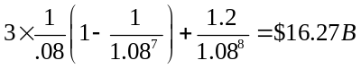
8-21. Using the FCF projections in part b of Problem 11, calculate the NPV of the HomeNet project assuming a cost of capital of
a. 10%.
b. 12%.
c. 14%.
What is the IRR of the project in this case?
a.
 |  | Year | 0 | 1 | 2 | 3 | 4 | 5
Net Present Value ($000s)
1 | Free Cash Flow |  | (16,500) | 2,470 | 6,580 | 10,421 | 12,860 | 3,843
2 | Project Cost of Capital | 10%
3 | Discount Factor |  | 1.000 | 0.909 | 0.826 | 0.751 | 0.683 | 0.621
 |  | Year | 0 | 1 | 2 | 3 | 4 | 5
1 | PV of Free Cash Flow |  | (16,500) | 2,245 | 5,438 | 7,830 | 8,783 | 2,386
2 | NPV |  | 10,182
3 | IRR |  | 28.8%

b.
 |  | Year | 0 | 1 | 2 | 3 | 4 | 5
Net Present Value ($000s)
1 | Free Cash Flow |  | (16,500) | 2,470 | 6,580 | 10,421 | 12,860 | 3,843
2 | Project Cost of Capital | 12%
3 | Discount Factor |  | 1.000 | 0.893 | 0.797 | 0.712 | 0.636 | 0.567
 |  | Year | 0 | 1 | 2 | 3 | 4 | 5
1 | PV of Free Cash Flow |  | (16,500) | 2,205 | 5,246 | 7,418 | 8,172 | 2,181
2 | NPV |  | 8,722
3 | IRR |  | 28.8%
c.
 |  | Year | 0 | 1 | 2 | 3 | 4 | 5
Net Present Value ($000s)
1 | Free Cash Flow |  | (16,500) | 2,470 | 6,580 | 10,421 | 12,860 | 3,843
2 | Project Cost of Capital | 14%
3 | Discount Factor |  | 1.000 | 0.877 | 0.769 | 0.675 | 0.592 | 0.519
 |  | Year | 0 | 1 | 2 | 3 | 4 | 5
1 | PV of Free Cash Flow |  | (16,500) | 2,167 | 5,063 | 7,034 | 7,614 | 1,996
2 | NPV |  | 7,374
3 | IRR |  | 28.8%
8-22. For the assumptions in part (a) of Problem 5, assuming a cost of capital of 12%, calculate the following:
a. The break-even annual sales price decline.
b. The break-even annual unit sales increase.
a. 28.5%
b. 25350
8-23. Bauer Industries is an automobile manufacturer. Management is currently evaluating a proposal to build a plant that will manufacture lightweight trucks. Bauer plans to use a cost of capital of 12% to evaluate this project. Based on extensive research, it has prepared the following incremental free cash flow projections (in millions of dollars):
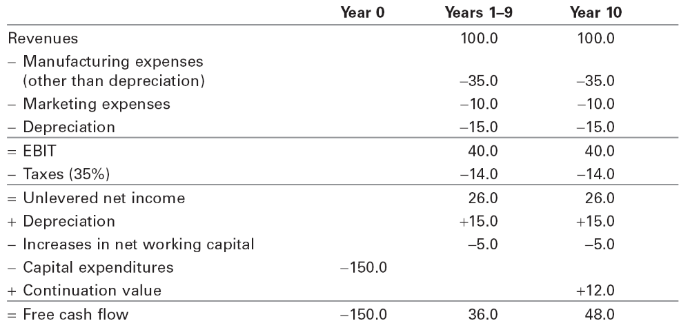
a. For this base-case scenario, what is the NPV of the plant to manufacture lightweight trucks?
b. Based on input from the marketing department, Bauer is uncertain about its revenue forecast. In particular, management would like to examine the sensitivity of the NPV to the revenue assumptions. What is the NPV of this project if revenues are 10% higher than forecast? What is the NPV if revenues are 10% lower than forecast?
c. Rather than assuming that cash flows for this project are constant, management would like to explore the sensitivity of its analysis to possible growth in revenues and operating expenses. Specifically, management would like to assume that revenues, manufacturing expenses, and marketing expenses are as given in the table for year 1 and grow by 2% per year every year starting in year 2. Management also plans to assume that the initial capital expenditures (and therefore depreciation), additions to working capital, and continuation value remain as initially specified in the table. What is the NPV of this project under these alternative assumptions? How does the NPV change if the revenues and operating expenses grow by 5% per year rather than by 2%?
d. To examine the sensitivity of this project to the discount rate, management would like to compute the NPV for different discount rates. Create a graph, with the discount rate on the x-axis and the NPV on the y-axis, for discount rates ranging from 5% to 30%. For what ranges of discount rates does the project have a positive NPV?
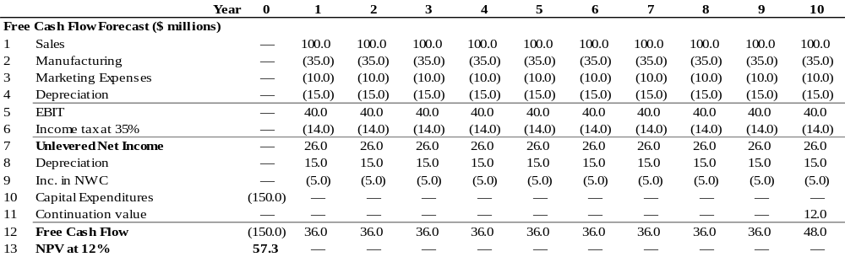
a. The NPV of the estimate free cash flow is
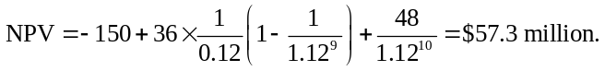
b. Initial Sales 90 100 110
NPV 20.5 57.3 94.0
c. Growth Rate 0% 2% 5%
NPV 57.3 72.5 98.1
d. NPV is positive for discount rates below the IRR of 20.6%.
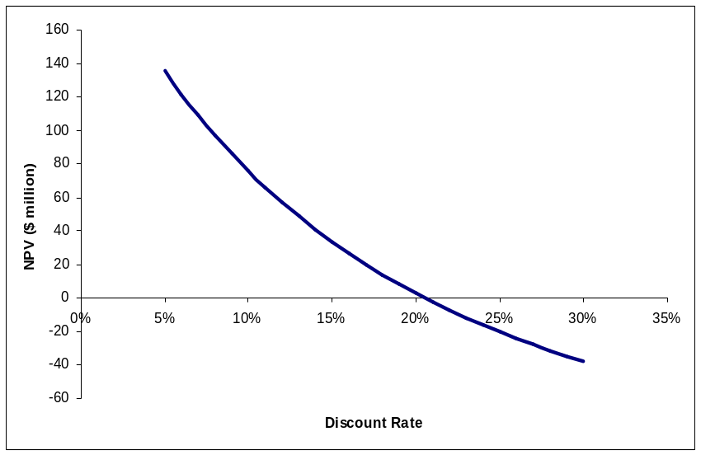
8-24. Billingham Packaging is considering expanding its production capacity by purchasing a new machine, the XC-750. The cost of the XC-750 is $2.75 million. Unfortunately, installing this machine will take several months and will partially disrupt production. The firm has just completed a $50,000 feasibility study to analyze the decision to buy the XC-750, resulting in the following estimates:
■ Marketing: Once the XC-750 is operating next year, the extra capacity is expected to generate $10 million per year in additional sales, which will continue for the 10-year life of the machine.
■ Operations: The disruption caused by the installation will decrease sales by $5 million this year. Once the machine is operating next year, the cost of goods for the products produced by the XC-750 is expected to be 70% of their sale price. The increased production will require additional inventory on hand of $1 million to be added in year 0 and depleted in year 10.
■ Human Resources: The expansion will require additional sales and administrative personnel at a cost of $2 million per year.
■ Accounting: The XC-750 will be depreciated via the straight-line method over the 10-year life of the machine. The firm expects receivables from the new sales to be 15% of revenues and payables to be 10% of the cost of goods sold. Billingham’s marginal corporate tax rate is 35%.
a. Determine the incremental earnings from the purchase of the XC-750.
b. Determine the free cash flow from the purchase of the XC-750.
c. If the appropriate cost of capital for the expansion is 10%, compute the NPV of the purchase.
d. While the expected new sales will be $10 million per year from the expansion, estimates range from $8 million to $12 million. What is the NPV in the worst case? In the best case?
e. What is the break-even level of new sales from the expansion? What is the break-even level for the cost of goods sold?
f. Billingham could instead purchase the XC-900, which offers even greater capacity. The cost of the XC-900 is $4 million. The extra capacity would not be useful in the first two years of operation, but would allow for additional sales in years 3–10. What level of additional sales (above the $10 million expected for the XC-750) per year in those years would justify purchasing the larger machine?
a. See spreadsheet below.
b. See spreadsheet below.
c. See spreadsheet below.
d. See data tables in spreadsheet below.
e. See data tables in spreadsheet below.
f. See spreadsheet below—need additional sales of $11.384 million in years 3–10 for larger machine to have a higher NPV than XC-750.
